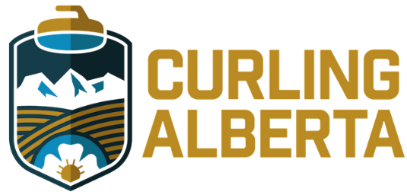

ALBERTA CURLING FEDERATION (operating as CURLING ALBERTA)
NOTICE OF NOMINATION FOR CURLING ALBERTA BOARD OF DIRECTORS

I, ________________________________, WISH TO PUT MY NAME FORWARD FOR CONSIDERATION FOR THE BOARD OF CURLING ALBERTA.
NAME: ____________________________________________

ADDRESS: ____________________________________________
____________________________________________

EMAIL ADDRESS: ____________________________________________

PHONE NUMBER ____________________________________________

GEOGRAPHIC AREA (GA) __________

__________________________________ ________________________
Nominee SIGNATURE DATE
MEMBERS IN GOOD STANDING (1 member club, from the same GA as the candidate must sign nomination form below)

______________________________________________________________
NAME (Club representative)

______________________________________________________________
SIGNATURE (Club representative)

______________________________________________________________
POSITION (club manager, president, etc)

_________________________________________________________
CURLING CLUB
Please submit completed nomination form, short biography and skills matrix to: Jody Meli, Chair, Governance Committee (board@curlingalberta.ca) by May 24, 2022 (11:59 pm MST)

BIOGRAPHY FOR __________________________________
Please provide background information, skills, key accomplishments and interests that you feel are important. Please highlight those skills referenced in the recruitment brief This information will be provided to members to facilitate the election process.
(please limit to one page)

