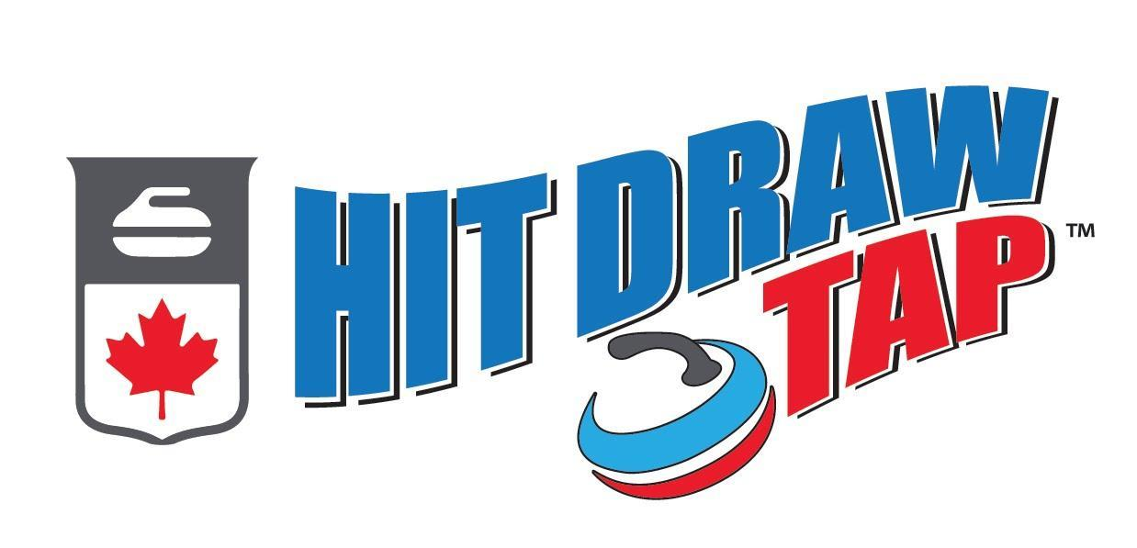

Curling Canada’s Hit Draw Tap Program

TABLE OF CONTENTS

1. About Hit, Draw, Tap 1
2. Eligibility 2
3. Rules 2
4. Club Registration 3
5. Hit, Draw, Tap Championship Skills and Scoring 3
6. The “Hit” 4
7. The “Draw” 5
8. The “Tap” 6
9. Reporting Scores 7
10. Recognition and Advancement 7

- ABOUT HIT, DRAW, TAP

***Any questions regarding Hit, Draw, Tap should be sent to Shannon Kleibrink, shannon.kleibrink@curlingalberta or 403-461-5498***

CurlON launched “Hit, Draw and Tap” in the 2015-2016 season. It was such a successful program that Curling Canada took over the program and they have shared it across Canada! “Hit Draw Tap” is modelled after the NFL’s “Punt Kick Pass” or Master’s Golf Drive Chip Putt”.

Curling Alberta is hoping the 2022-23 HIT DRAW, TAP competition will be bigger and better than ever before!

Hit Draw Tap (HDT) is a youth skills competition where kids ages 6-13 compete as individuals. HDT will group kids into three different age categories (6-8, 9-10 & 11-13). Competitors will perform three different shots – a “Hit,” a “Draw” and a “Tap.” The difficulties of the skills are modified based on the age of the child. A hosting kit will be emailed to the HDT Club Organizer.

Curling clubs across Alberta are encouraged to host a HDT competition as part of their Junior Program whenever it best suits them. We anticipate that each club will need an hour and a half to two hours to complete their competition. All we ask is that all competition results must be entered into the Curling Canada database by Friday, January 20th, 2023 at 12:00 pm.

All participants will be compared to those in similar age groups from clubs across the province on a “Provincial Leaderboard” that can be accessed online by the public at: www.hitdrawtap.ca. The top 5 participants from each category will qualify to compete in the Provincial Hit, Draw Tap competition to be held during the Boston Pizza Cup Men’s Provincial Championships at the River Cree Resort and Casino in Edmonton, AB on Saturday, February 11th, 2023.

Participants are responsible for all travel costs to and from the event.

Participants don’t need to be a curler or a member of a club to compete. Encourage players to bring a friend to your HDT competition!

- ELIGIBILITY

- The competition is open to all boys and girls ages 6‐13. Boys and girls compete against each other, but in their appropriate age categories.
- The three age classifications are based upon the child’s age as of December 31st, 2022.

Age Categories (as of December 31st, 2021)

If you were born in: | Age Group:
2016,2015, 2014 | 6-8
2013,2012 | 9-10
2011,2010,2009 | 11-13

- All participants may be asked to show proof of age at the Provincial Level of competition.
- All participants’ guardians must complete a Hit, Draw and Tap Participant Registration Form/Assumption of Risk Form.

- RULES

- No brushing is allowed during the competition.
- Regulation curling rocks (i.e. no Little Rocks or Lite Rocks) are to be used by all age categories.
- Full sheet length (unless at 6-8 age modification- see details below) is to be used.
- Someone (parent, volunteer or other curler) can hold the broom for the thrower.
- All athletes must wear head protection deemed appropriate by club organizers, clean running or curling shoes
- All participants’ guardians must sign the Participant Registration Form/Assumption of Risk Form before participating in any Hit, Draw & Tap competition.
- Each participant is allowed two practice shots (participant can choose whether they practice draws or hits) prior to their shots being scored.
- Provincial Finalists will be given access to the ice for a 10 minute open practice session/age category.
- Scores are cumulative per event, with each participant repeating each score five times.
- Ties at the club and provincial level will be broken to determine 1st, 2nd and 3rd with a “sudden death” draw to the button – draw is repeated until winner is determined. Officials at provincials will measure the distance from the pin to determine the winner if the first tiebreaker draw is unable to determine a winner by score.
- If at any point a decision cannot be made as to the score of a shot, the decision shall always favor the participant.

- CLUB REGISTRATION

Curling Clubs are to register their event online at https://ab.curling.io/en/products/6316-hit-draw-tap-registration-2022-23
Club Participation Cost: $50.00

Registration should be made by the person, who will be responsible for the event, that person will be given “User” rights in the Online-Scoring site.

There is no charge to the participants to enter this event. Each club may charge a nominal entry fee should they wish to offset any expenses from the club event or as a fundraiser to their club.

Once registered, each club will receive a HDT hosting package consisting of:
- Participation Certificates
- Manual Scoring Forms
- Online Scoring App Tutorial

- HIT, DRAW, TAP CHAMPIONSHIP SKILLS AND SCORING

Pre-Competition Practice
It is recommended that each participant be permitted a maximum of two practice shots or an open practice time – whichever best suits the club. An open practice of 10 minutes will be permitted at the provincial finals.

Scoring
Each athlete will have five attempts at each shot. The score is cumulative. In all situations, if a score cannot be clearly determined, the decision shall be made in the favour of the participant (i.e. round up to the higher of the two scores).

Game Modification
6-8 year olds shall throw from the hack to the near/”throwing” house in a “short game” format.

THE “HIT”

Goal: Hit the positioned rock and stay in the rings.
Age Group | 6-8 | 9-10, 11-13
Modification | Short Game | None
Special Rules | - Must keep their hack foot in their designated hack (i.e. right handed thrower uses left hack).  - Contact with the set-up stone must be made for the any points to count, the stone does not have to be removed from play. | - Must keep their hack foot in their designated hack (i.e. right handed thrower uses left hack).  - Contact with the set-up stone must be made for the any points to count, the stone does not have to be removed from play
Set-up | Rock to be hit, is set up just behind the button.
Scoring | Points are assigned by where the shooter rolls to:  - 5 points if it touches the button  - 4 points if it rolls but touches the four foot  - 3 points if it rolls touches the eight foot  - 2 point if it rolls touches the 12 foot  - 1 point if the rock is removed from play and the shooter rolls out of the rings.  **Contact with the set stone must be made for any points to count. Stone does not have to be removed from play.
Diagram | 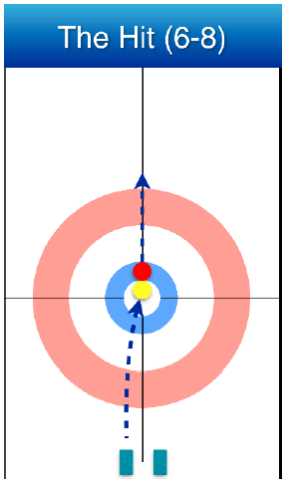 |  | 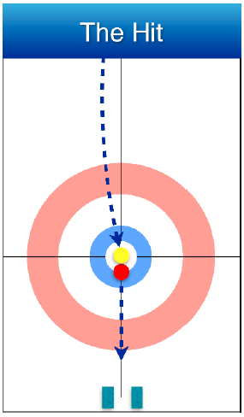

THE “DRAW”

Goal: Draw as close to the pin as possible.
Age Group | 6-8 | 9-10, 11-13
Modification | Short Game | None
Special Rules | - Must keep their hack foot in their designated hack (i.e. right handed thrower uses left hack). | Must keep their hack foot in their designated hack (i.e. right handed thrower uses left hack).
Set-up | None
Scoring | Points are assigned by where the shooter stops:  - 5 points if it covers the pin  - 4 points if it touches the button  - 3 points if it touches the four foot  - 2 point if it touches the eight foot  - 1 point if the touches the 12 foot |  | Points are assigned by where the shooter stops:  - 5 points if it touches the button  - 4 points if it touches the four foot  - 3 points if it touches the eight foot  - 2 point if it touches the twelve foot  - 1 point if the rock stops in the free guard zone
Diagram | 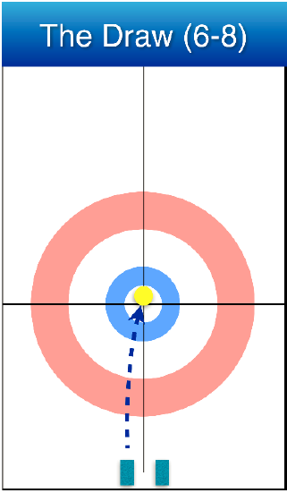 |  | 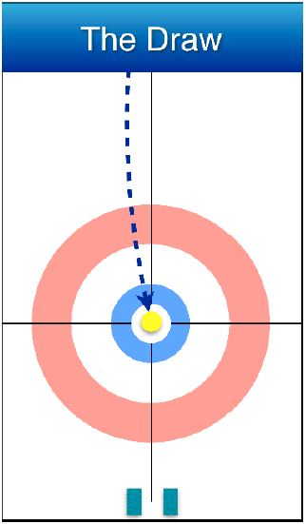

THE “TAP”

Goal: To promote a rock from the 12’ to the button.
Age Group | 6-8 | 9-10, 11-13
Modification | Short Game | None
Special Rules | - Must keep their hack foot in their designated hack (i.e. right handed thrower uses left hack). | Must keep their hack foot in their designated hack (i.e. right handed thrower uses left hack).
Set-up | Rock is positioned bisecting the centre line, at the top of the rings.
Scoring | Points are assigned by where the tapped rock stops:  - 5 points if it touches the button  - 4 points if it touches the four foot  - 3 points if it touches the eight foot  - 2 point if it touches the twelve foot  - 1 point if contact is made but the rock goes through the rings |  | Points are assigned by where the tapped stops:  - 5 points if it touches the button  - 4 points if it touches the four foot  - 3 points if it touches the eight foot  - 2 point if it touches the twelve foot  - 1 point if contact is made but the rock goes through the rings
Diagram | 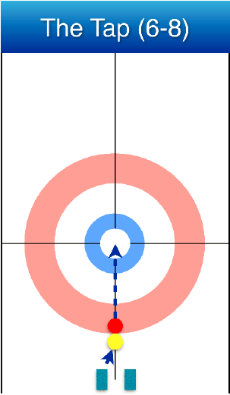 |  | 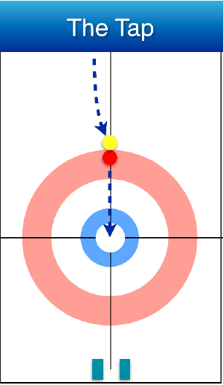

- REPORTING SCORES

A Web based Scoring Application will be available. The instructions/access to this tool will be sent to the club’s event contact.

If you do not have access to internet on-ice you may want to utilize a manual record form. You will then need to transcribe the information into the web based scoring application for the information to appear on the provincial leaderboard. If assistance is needed with adding the scores online please contact Shannon Kleibrink at shannon.kleibrink@curlingalberta.ca.

All results must be entered by Friday, January 20th, 2023 at 12:00 pm.

- RECOGNITION AND ADVANCEMENT

Each participant will receive a Participation Certificate.

Advancement to Provincials
The top 5 participants from each category will qualify to compete in the Provincial Hit Draw Tap Championship taking place at the 2023 Boston Pizza Cup Men’s Provincials at the River Cree Resort and Casino on Saturday, February 11th (Time TBA).

- Participants are responsible for all travel costs to get to and from the event.
- Parents/Guardians of participants who have qualified for provincials will receive an email communication on or around January 20th, 2023 to confirm their child’s attendance at the provincial competition.
- All Provincial Participants will receive
  - Tickets for themselves and one guest to watch the semi-final draw at the Boston Pizza Cup Men’s Provincial Championships on Saturday, February 11th, 2023.
  - Group Photo (sent via email post-event)
- Top Finishers in each category will receive medals.
- Winners will have their names engraved on the Hit Draw Tap Trophy.

